Lab 6

Section #1: Launching an Application in AWS Elastic Beanstalk

In this section, we will deploy a default website using AWS Elastic Beanstalk.
“AWS Elastic Beanstalk makes it even easier for developers to quickly deploy and manage applications in the AWS cloud. Developers simply upload their application, and Elastic Beanstalk automatically handles the deployment details of capacity provisioning, load balancing, auto-scaling, and application health monitoring.”
Source: http://aws.amazon.com/elasticbeanstalk/faqs/

Part A:

- Login into AWS with your IAM user.
- Create a new role named “aws-elasticbeanstalk-ec2-role”. (You made one for S3 in other lab)
  - IAM > Roles > Create role
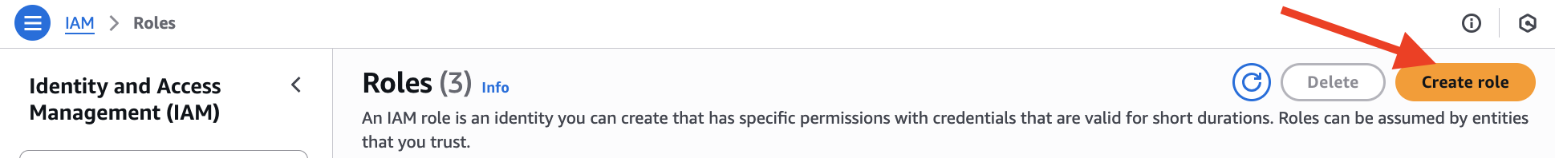
  - For Step 1 Select trusted entity:
    - Choose “AWS service” (default) for “Trusted entity type”.
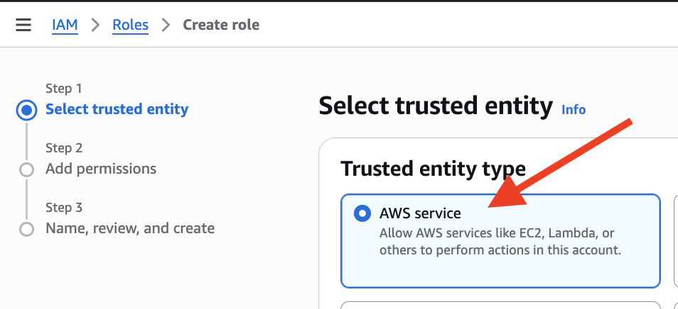
    - Select “EC2” for “Service or use case.”
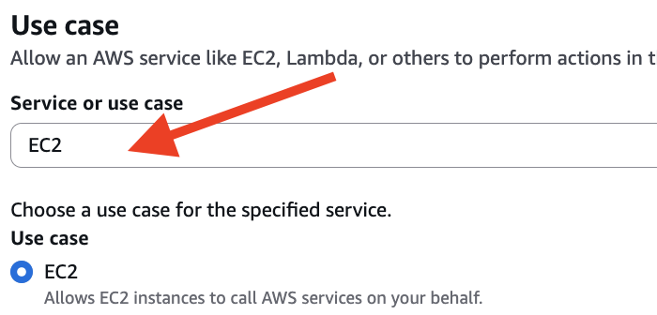
  - Click Next button to proceed to Step 2.
  - For Step 2 Add permissions, search for “elasticbeanstalk”
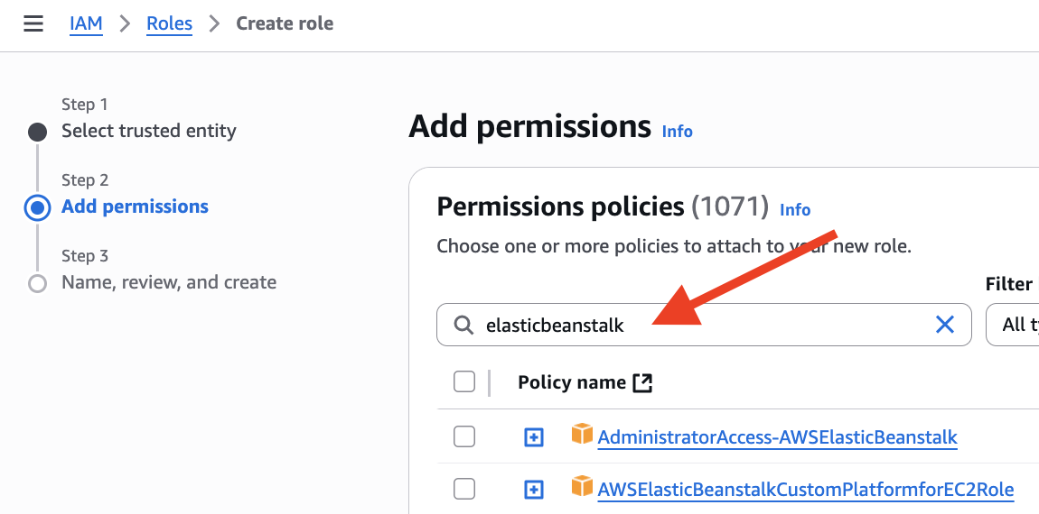
  - Select “AWSElasticBeanstalkMulticontainerDocker” permission
  - Add “AWSElasticBeanstalkWebTier” permission
  - Add “AWSElasticBeanstalkWorkerTier” permission
  - Click Next button to proceed to Step 3.
  - Type in role name: aws-elasticbeanstalk-ec2-role
  - Click Create role button to proceed.
- From the Services menu, search and select “Elastic Beanstalk”.
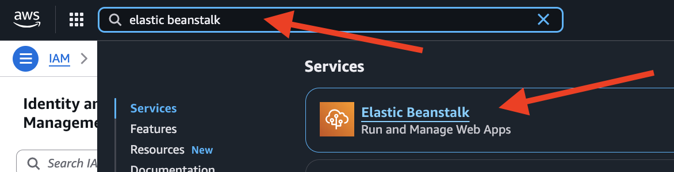
- In the top right corner of the screen, click on the Create application button.
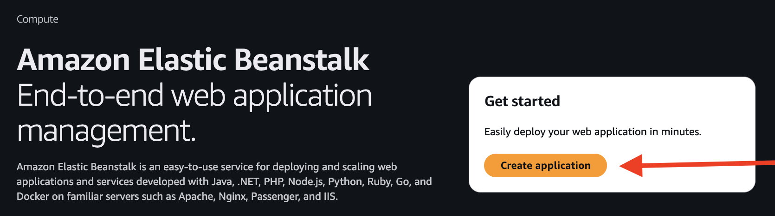
- Use default “Web server environment” for Environment tier.
- Enter a name for Application Name like “LabPartA”.
- In “Platform” section, select “Tomcat” from the Preconfigured choices.
- In “Application code” section, use the default “Sample application”.
- In “Presets” section, use the default “Single instance (free tier eligible)”.
- Click Next button to proceed to “Step 2”.
- Create a new role for Service role, steps:
  - Click the “Create role” button
  - Step 1: defaults: “AWS service” and “Elastic Beanstalk - Environment”, click “Next”
  - Step 2: defaults policies, click “Next”
  - Step 3: no tag, click “Create role”
  - Should see new role created: aws-elasticbeanstalk-service-role
- Back to Elastic Beanstalk > Create environment, Step 2: Configure service access
  - Refresh for Service role, should see “aws-elasticbeanstalk-service-role”
  - Use the default value “aws-elasticbeanstalk-ec2-role” for “EC2 instance profile”
  - Choose your own key pair for “EC2 key pair”.
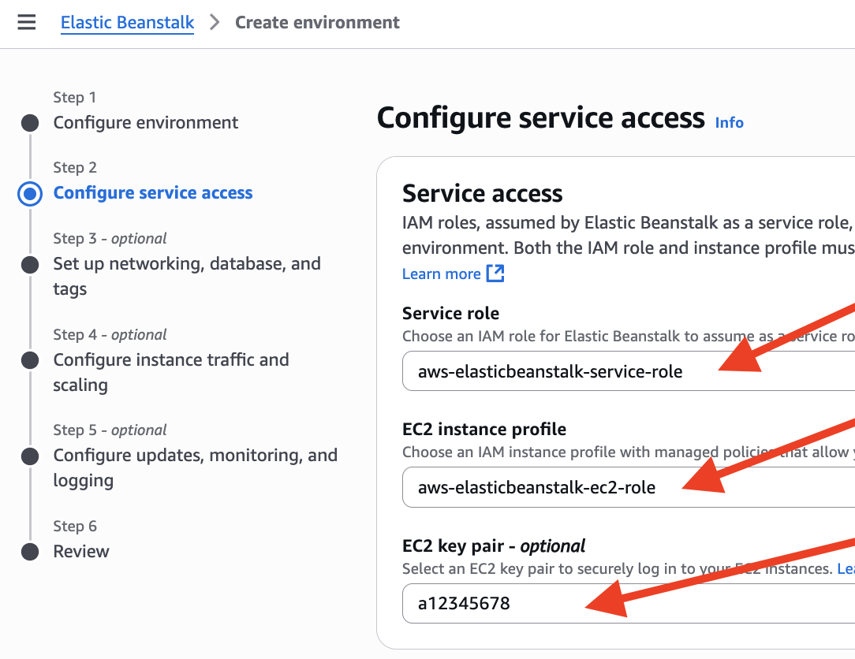
- Click Next button to proceed Step 3.
- Go with all defaults for Step 3, click Next button at the page bottom to proceed to Step 4.
- For Instance types: choose t3.micro and remove the given t3.small
- Click Next button at the page bottom to proceed to Step 5.
- Go with all defaults for Step 5, click Next button at the page bottom to proceed to Step 6.
- Review settings, click Create button to proceed.
- Monitor the activities in the Events tab while your EB environment is being built.
- What activities are occurring?
- Messages should be displayed indicating that an instance is being created, a security group, and Elastic IP Address (EIP), etc.
- While the Beanstalk environment is being created, open another browser window or tab. Log into AWS and go to your EC2 Dashboard, you should see an instance got created.
- In the same browser window, navigate to S3. Has an S3 bucket been created?
- Continue to monitor your Beanstalk environment.
- [Optional] If you receive an error saying that the environment could not be created, it means an S3 bucket has not been created. Do the following:
  - Click on “Elastic Beanstalk” in the top left of your screen to return to the home page.
  - Click the button “Create New Application.”
  - Click the Cancel button. This will create an S3 bucket.
  - Go back to Step 5, above.
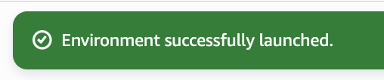
- After a few minutes, you should see a message that says, you should eventually see this message:
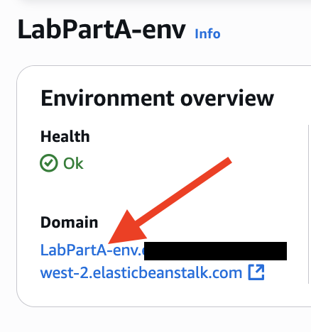
- When your environment is ready,

click on the blue hyper-link domain.

- This may take some time, be patient. You should see a webpage that says, “Congratulations!”
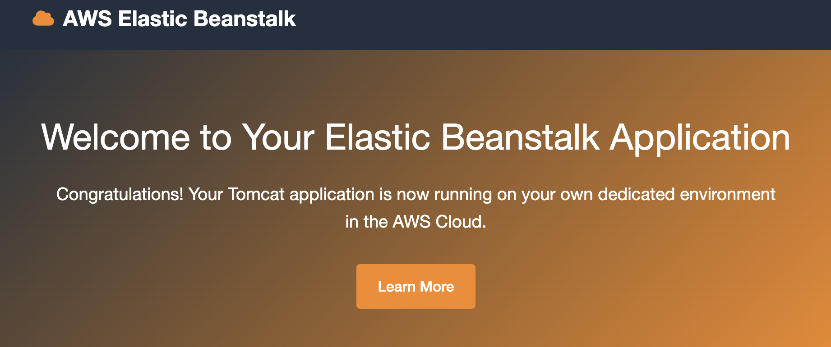

Now you are going to change this webpage to display your name or initials.
- Go to your EC2 instances dashboard.
- Click on the Security Group associated with the instance. Do you have inbound SSH access to this instance? (You should.) The one is with Port 22
- Connect to this instance using SSH. The username needs to be “ec2-user”
- Navigate to this directory: /var/lib/tomcat11/webapps/ROOT
This directory contains the website’s homepage called “index.jsp.”
If you don’t have the directory above, try: cd into /var/lib/ to find out what your tomcat is going with what folder name (could be “tomcat”, “tomcat10”, etc.)
- Use a Linux text editor, like nano or vi, and open the index.jsp file. You may have to use “sudo” to open and change the file and/or chmod. Eg, sudo nano index.jsp
- Find the word “Congratulations!” and change it to your initials and A# last 3 digits.
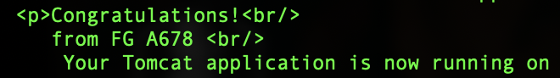
- Save & close the file. (Control + O to save, Control + X to exit)
- Close your SSH connection. (command: exit)
- Refresh your browser that contains the Congratulations web page. You should see your updated message got displayed. I got this:
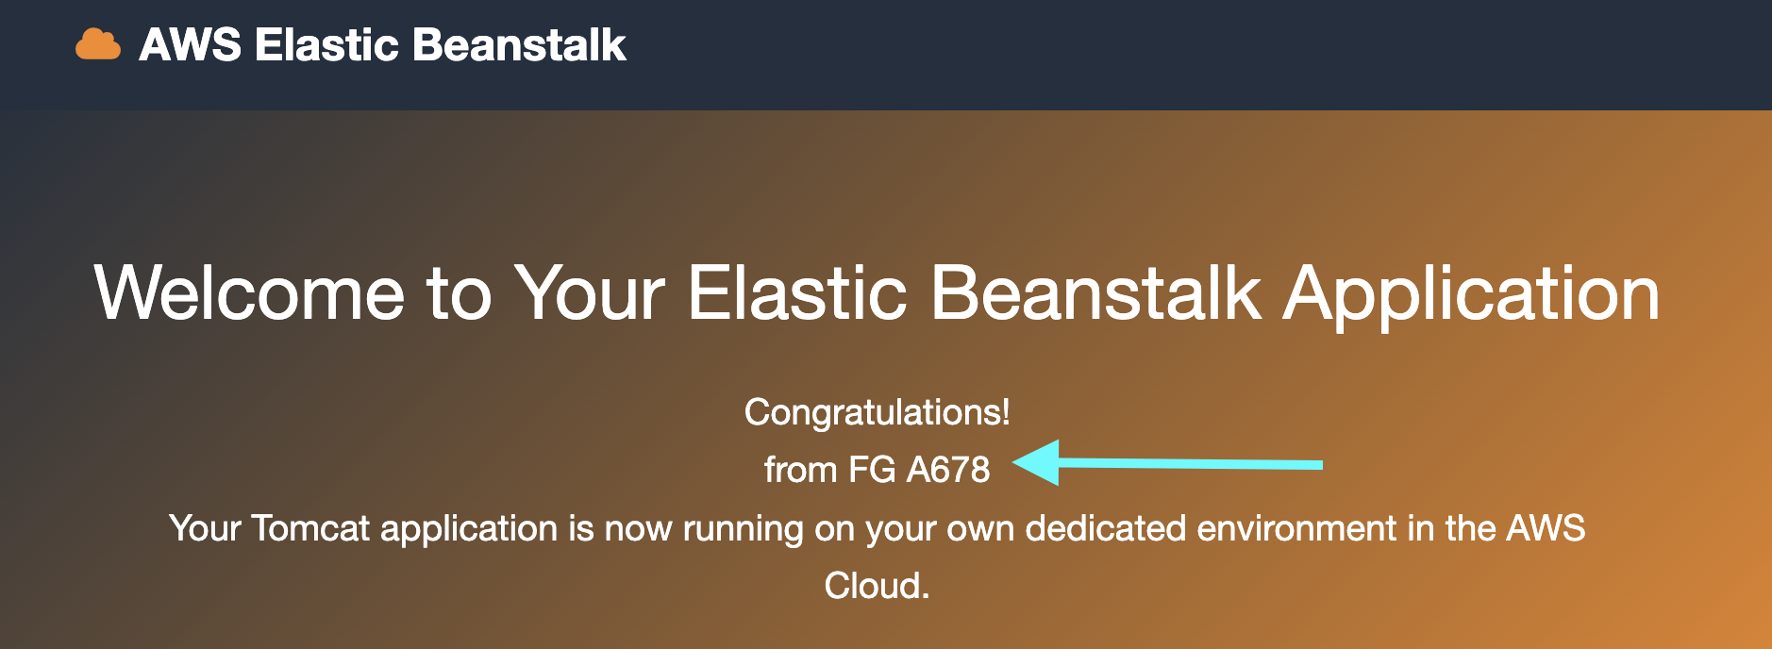
- Go to your instructor to get sign-off. You are expected to show:
  - One screen to show the S3 bucket created by Beanstalk
  - One screen of your browser showing updated homepage as and “Congratulations” followed by your initials and last 3 digits of A#.
  - One screen showing your running instance (IP needs to match) created by Beanstalk.
  - One screen showing your Beanstalk application.
  - One screen showing your Beanstalk environment.
- After you got all above, clean up as follow:
  - Terminate the Elastic Beanstalk environment using the Actions button on the Elastic Beanstalk dashboard page. This should terminate the instance.
  - Wait a few minutes and then check your EC2 instances. Is it still running? If it is, terminate the AMI used with the Elastic Beanstalk.
  - Delete all applications in Elastic Beanstalk, if not deleted automatically.
  - You may keep the S3 bucket for now. Delete it after finishing Part B.
➔ Your teardown will be checkout (sign-off) later after Part B.

Part B: Node.js website

- Fairly similar to Part A, make a Beanstalk Sample application with Node Platform.
- Enter a name for Application name like “LabPartB”.
- For Platform, choose “Node.js”
- In Step 2, reuse “aws-elasticbeanstalk-service-role” and “aws-elasticbeanstalk-ec2-role” from Part A
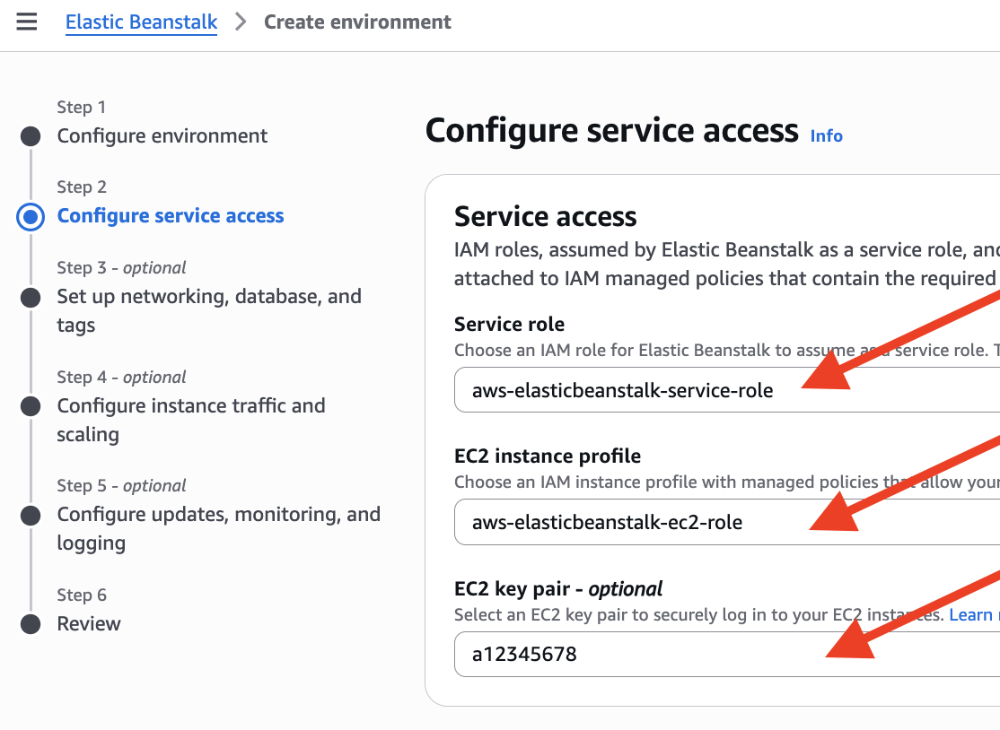
- In Step 4, choose t3.micro (with removing t3.small) to avoid get charged.
- When your application is ready, you should see something like this:
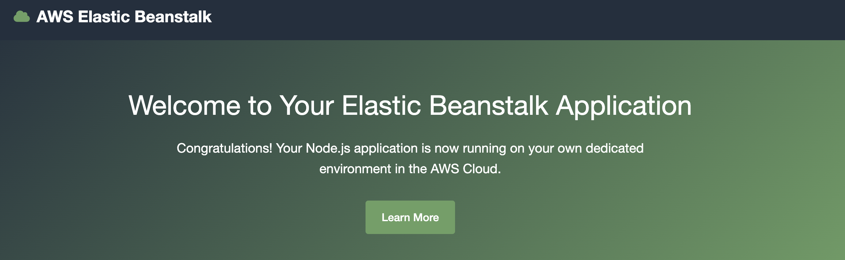
- Show listed items to your instructor to get sign-off:
- One screen of your browser showing default homepage with “Congratulations”
- One screen showing your Beanstalk application.
- One screen showing your Beanstalk environment.

8. [Optional] To change the default home page.

Teardown
  - Terminate the Elastic Beanstalk environment using the Actions button on the Elastic Beanstalk dashboard page. This should terminate the instance.
  - Wait a few minutes and then check your EC2 instances. Is it still running? If it is, terminate the AMI used with the Elastic Beanstalk.
  - Delete all applications in Elastic Beanstalk, if not deleted automatically.
  - Empty and then delete the S3 bucket. If you failed to delete the bucket, you need to revise the delete permission for your bucket (“Deny” ➔ “Allow”):
- Select the bucket and then open the “Permissions” tab
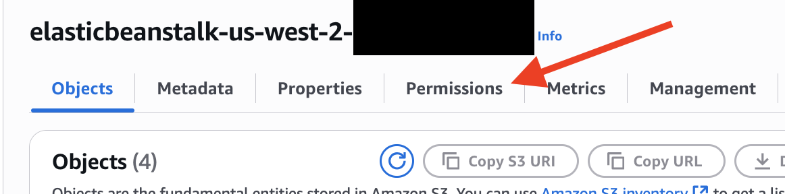
- Scroll down and click Edit button for “Bucket Policy”
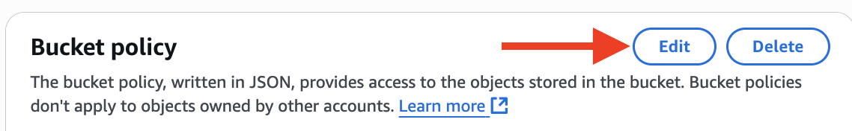
- Change “Deny” to “Allow” for “delete bucket” and then Save changes

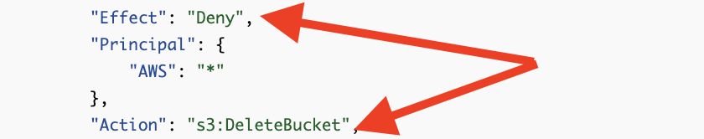

- Then you can delete the bucket.
Let your instructor know you completed the termination step to get a sign-off for teardown.
- Elastic Beanstalk, Environment, application
- EC2, EIP
- S3

Section #2: ES6 Part 1

2.1 Introduction of ECMAScript 6
What is ECMA?
ECMA is the organization responsible for defining a standard for the JavaScript programming language, also known as ECMAScript. They have committed to yearly updates to the JavaScript language, although each browser is free to implement them at their own pace.
What is ECMAScript?
ECMAScript is a standardized name for JavaScript.
What is ECMAScript 6?
ECMAScript 6 (AKA. ES6) is also known as ECMAScript 2015. This is the first version of JavaScript where major improvements have been made. Most modern browsers support most of the ES6 features natively by now, but in order to support backwards compatibility, "transpiling" can be used to "translate" and "compile" to ES5.
You are not required to know all ES6 features, as some of them are not even supported
in some browsers yet. There are a few though, that are very useful, and I recommend that you are familiar with them.
What's after ES6?
ES7, ES8, ES9 and so on. Some of the features in these ECMAScript versions are also available to use in modern browsers. You can also use transpiling tools like Babel, to use these newer features with backwards compatibility.

2.2 Feature in ES6: let & const
2.2.1 New key word: let
The first new feature we'll look at is a new keyword in ES6, the let keyword. It, the “let”, allows us to define variables.

We've always had the ability to define variables in JavaScript, and we've done this with the var keyword. However, the var keyword has some limitations when it comes to scope. The scope of a variable defines the area of a program where the variable is legal to use, but with “var” there are only two types of scope for a variable:
- Global scope: for variables with var outside of any function.
- Function scope: for variables defined inside a function.

And there is no block scope, and this is a source of confusion and occasionally bugs, particularly if you come from a background of using one of the other many languages that use curly braces to define blocks of code.
For example,
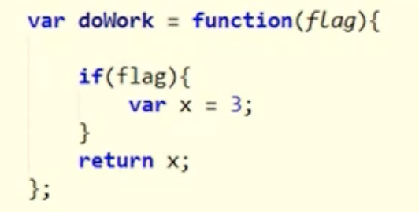
It looks like I have a variable defined as x that lives inside of the if statement, but in reality, because var can only give us function-scoped variables, x is available throughout that function, and the return keyword is going to work perfectly well. Because there is going to be a variable named x inside of doWork function, and that is the problem that let will solve.

The let keyword will give us true block scoping. The second code snippet will generate an error if there's no other x variables defined in an outer scope.
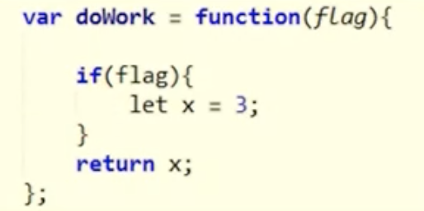
There will be an error, because x is only available to use inside of the if block. It is great to help us find this type of bug in our code.

2.2.2 New key word: const
The const keyword is another addition in ECMAScript 6. This one can be a bit confusing depending on the tools you are using, and only because const has been around. Not as part of any official ECMAScript language specification, but the V8 engine has recognized a const keyword for some time, so you might have seen it used in Chrome or Firefox.

The idea is, as the name suggests, to create and initialize a read-only variable, a variable that will hold a constant value and something that you can never change. In ECMAScript 6, const will have block-scoping, just like the let keyword.

2.3 Feature in ES6: Destructuring
When we declare variables with var, let, and const, we typically also want to initialize the variable by assigning a value, and one of the new features of ES6 is the ability to use a destructuring assignment.

Destructuring is an operation you might have seen in other languages like Python or Ruby. What the destructuring operation allows you to do is assign values to a set of variables by destructuring, or literally tearing apart and pattern matching a complex data structure like an array or an object full of properties. This sounds complicated, but if you've never destructured before, I think you'll find it intuitive after a little practice. For example,

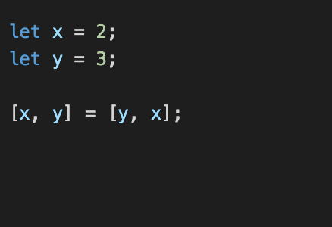
The first two lines are declaring the variables x and y, and assigning the values 2 and 3 respectively.

Then in the middle, we use a destructuring assignment to say, give the variables x and y the values y and x. We are not creating a new array, instead we are going to move the 3 from the y into the x and the 2 from the x into the y.

The end result is that we've swapped those values in x and y, and this is one example of destructuring, but there's a lot more we can do, let's take a look of this one:
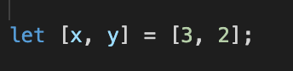
It's very important to understand that what we see on the right-hand side of this assignment is an array, it's an array built with the values that are in y and x. But what we see on the left-hand side of this assignment is not an array, it looks like an array literal, but really we are working with individual variables x and y, and we are surrounding them with square brackets because we are destructuring an array. In other words, we are telling JavaScript to take the first value of that array and put it into x, and take the second value of that array and put it into y.
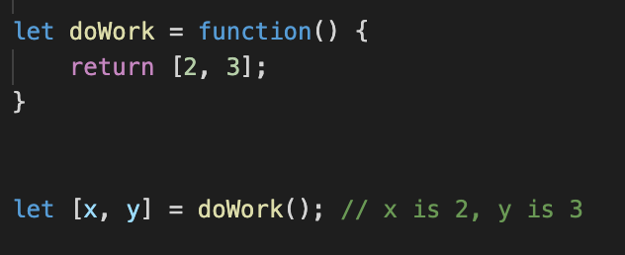
We could even have this array be returned from a function, so with a function called doWork that returned an array.

We could invoke the function and destructure the result into variables x and y, which is what should happen now.

Now, what if this array contained an additional 1 at the beginning of the array?

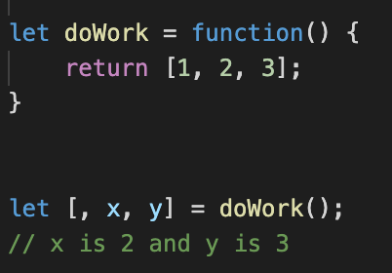
Well, in this case, if we want x to take the second value and y to take the third value, inside of this destructuring assignment we can always use a comma with no symbol there in any position where we just want to skip some value.

We could use that empty comma at the beginning, at the end, anywhere in the middle.

What would happen if there were an additional variable z? What would I expect z to be?
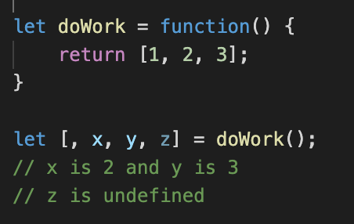
In JavaScript, if you try to get to something that is not there, like the return value of a function that doesn't return something or the value of a function parameter that wasn't passed, you'll get undefined, and that's also what happens in this case.

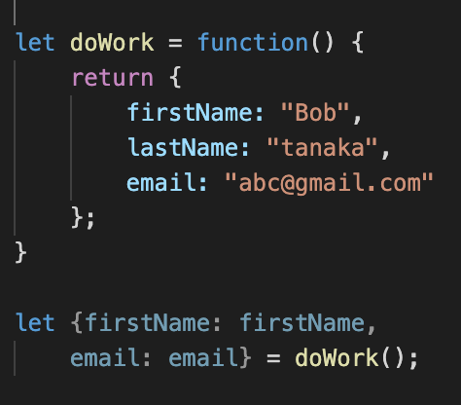
Let's also look at a similar scenario where we have a function called doWork, but this time, instead of returning an array it's returning an object with first name, last name, and email properties.

Let's say we want to take those values from the object and put them into individual variables, so we want a first name variable and an email variable. We can do that with curly braces, it looks like I'm building an object literal, but I'm really not, and the syntax here can be a little bit confusing.

For more details, check out Deep matching

2.4 Feature in ES6: Arrow Functions
Arrow functions introduce a concise syntax for defining a function of executable code, and this compact syntax is a wonderful feature to have in a programming language like JavaScript, because we create functions and pass functions as parameters quite frequently. The code below demonstrates what an arrow function looks like:
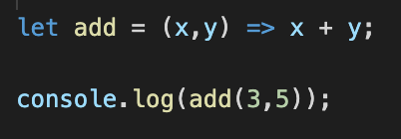
We are creating a function and assigning it to the variable add. We can then invoke add to get some sort of result. The arrow function gets its name from the two-character symbol used in the function expression the = and >, it looks like an arrow pointing to the right. Other languages have this same feature, and they call this operator the rocket, the fat arrow, or the Lambda operator, but the ES6 specification uses the term arrow function.

On the left-hand side of the arrow will be the function parameters for the function. In this case we have two parameters, and we give them the name x and y. They have to be surrounded by parentheses. Then on the right-hand side of the arrow is the function body. This is the code that we want to execute when the function is invoked. In this example, we just want to compute the sum of x and y. We do not need curly braces or a function keyword or even a return statement. JavaScript will know that we just want to add these two numbers and return the result. So the function is short and to the point. There's no code ceremony required with curly braces and keywords. It's a very short and expressive statement.

Notes:
- When using arrow functions, the key word “function” is not needed.
- When there is one and only one input parameter, the parentheses are optional.
- When there is one and only one statement in the function, the {} and return keyword is optional.
Arrows and Asynch
You'll probably come across situations where you want to use arrow functions as a callback for some asynchronous activity. We are going to talk more about asynch programming later in this course, but I want to cover a special feature of arrow functions at this point.

Most JavaScript code has a lot of asynchronous behavior inside, because every time we need to communicate over the network or wait for an event, we need to use callback functions and the arrow gives us a terse syntax for creating those functions. But one problem with callbacks is managing the “this” pointer inside of code, because the “this” reference inside of any piece of JavaScript code will be established by the context of how a particular function is invoked.

So, if we invoke a function through an object, like e1. doWork, I'll have a “this” reference that points to the object e1, but if I invoke a function as a callback from inside of doWork, the “this” value inside of that function can be different, it can point to global scope instead of the object.

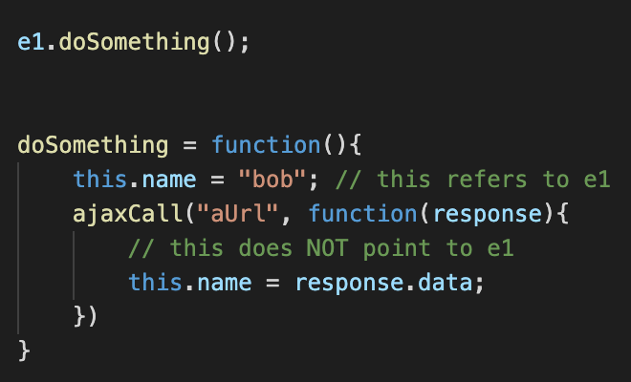

So, you see the problem. And the fix is simple, just revise the function with an arrow function.

2.5 Feature in ES6: Default Parameters
Simple and intuitive default values for function parameters.

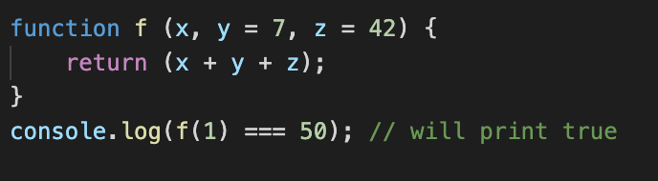

Notes: the default parameters are the right-most of the parameter list

